Exp no:8 -Determination and plotting of Capacitance of Co-axial cable per unit length with different (i) inner radius, (ii) outer radius and (iii) relative permittivity of the dielectric medium.
Aim: To write program for Capacitance of co-axial cable per unit length using
SCILAB. Software required:
•SCILAB version 6.0.1
Theory:
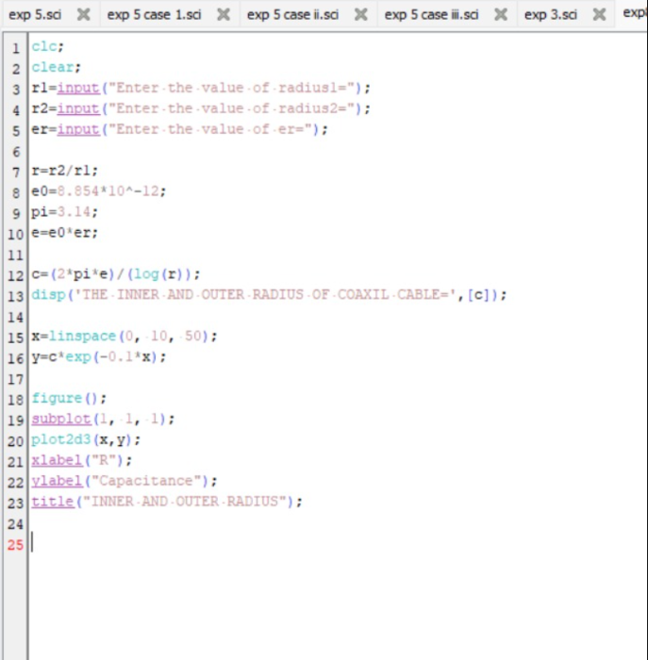
Output:
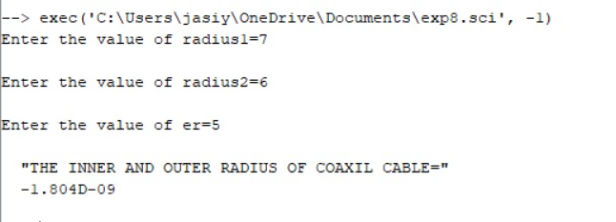

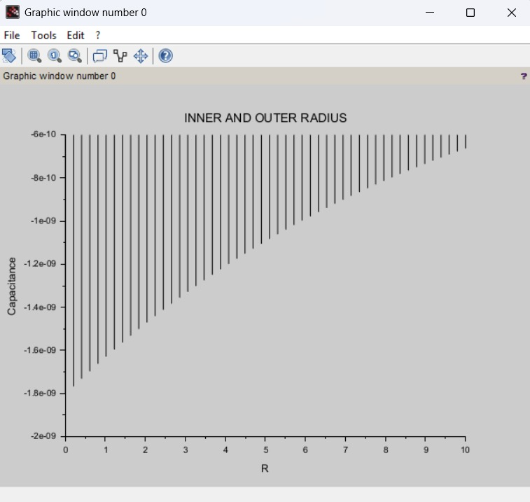

Calculation:
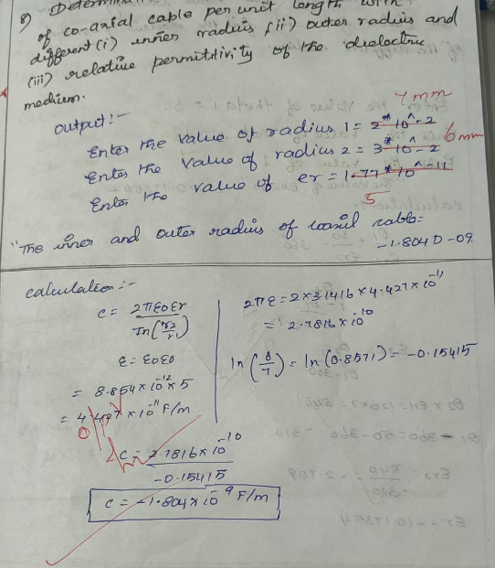
Calculation:
CASE STUDY 1: Variation with Inner Radius
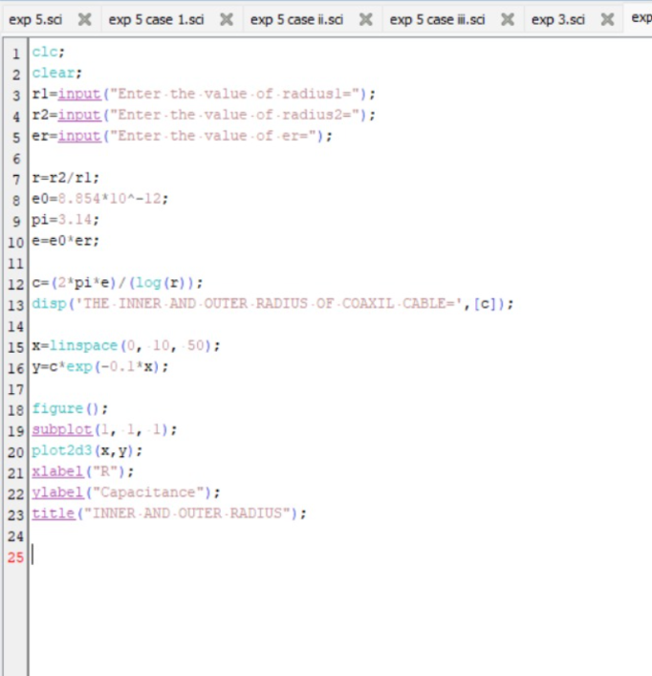
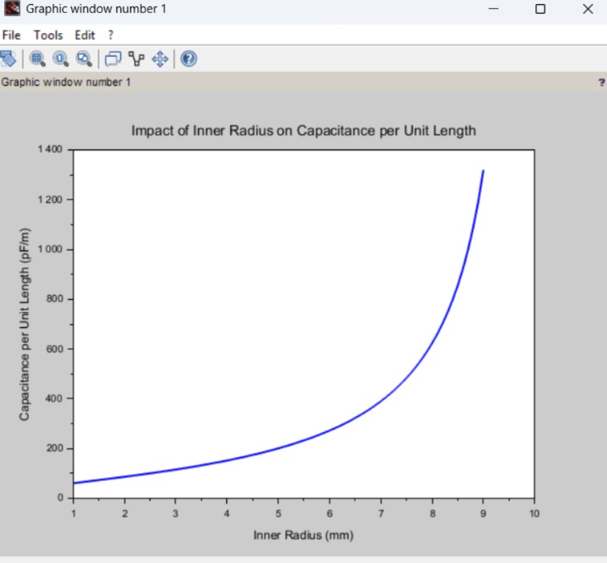

CASE STUDY 2: Variation with Outer Radius
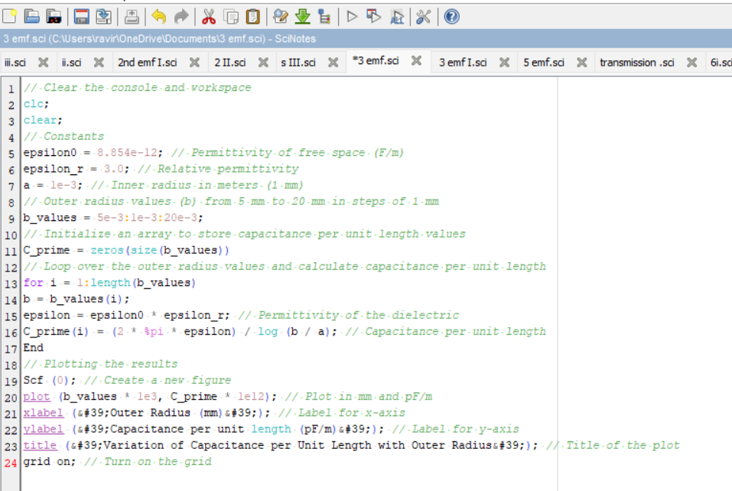
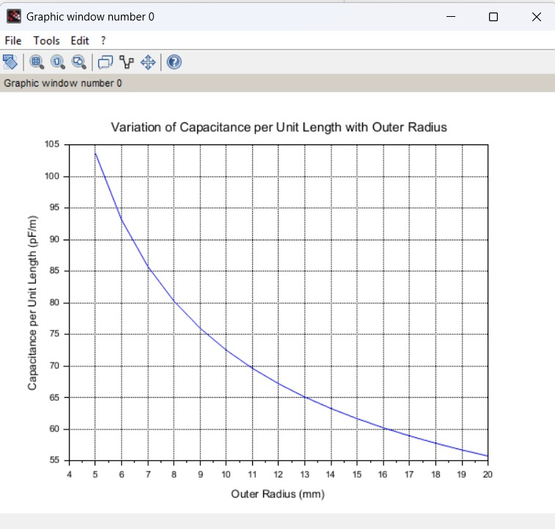

CASE STUDY 3: Variation with Relative Permittivity
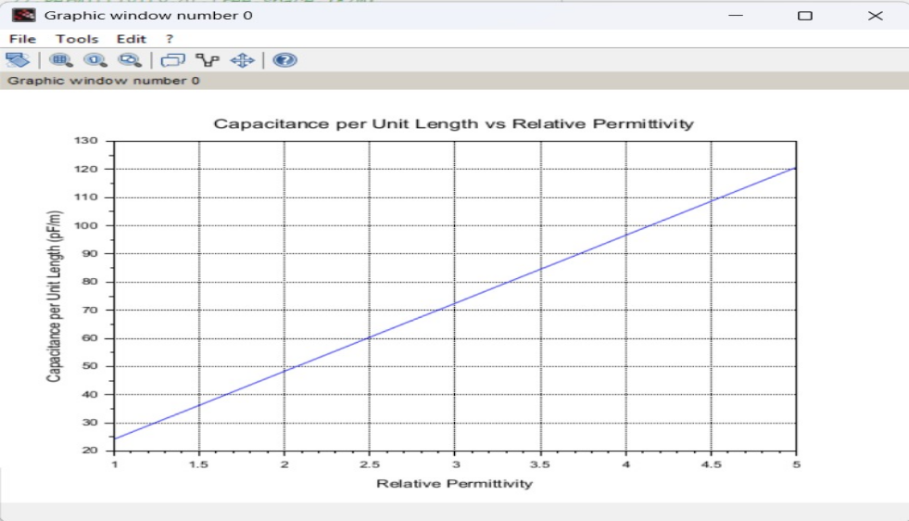
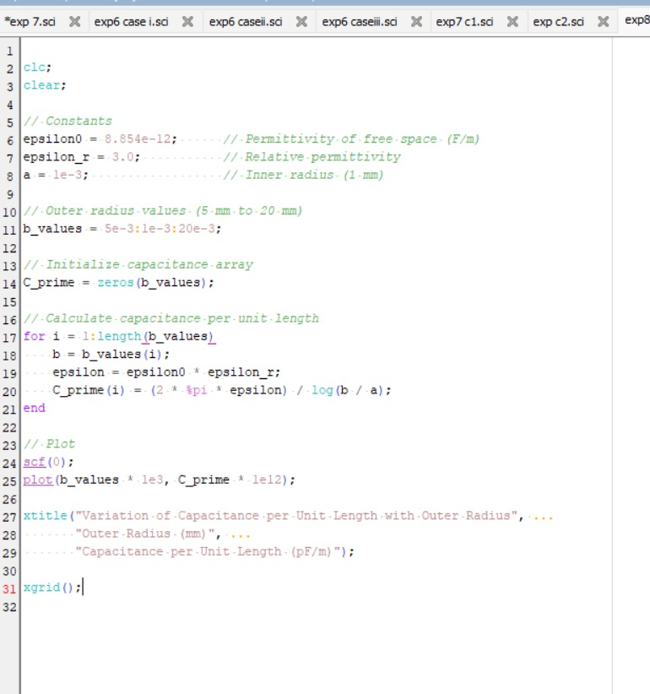

Result : Thus the program was verified for Capacitance of co-axial cable per unit length using SCILAB was successfully.

